Bahria University,

Karachi Campus

## LAB EXPERIMENT NO.

09

## LIST OF TASKS

|  |  |
| --- | --- |
| **TASK NO** | **OBJECTIVE** |
| **1** | Configure the given AI planner in your system |
| **2** | Provide the solution for dockworkerrobot problem using AI Planner |
|  |  |

Submitted On:

01 May 2024

(Date: DD/MM/YY)

**TASK # 1:** Configure the given AI planner in your system

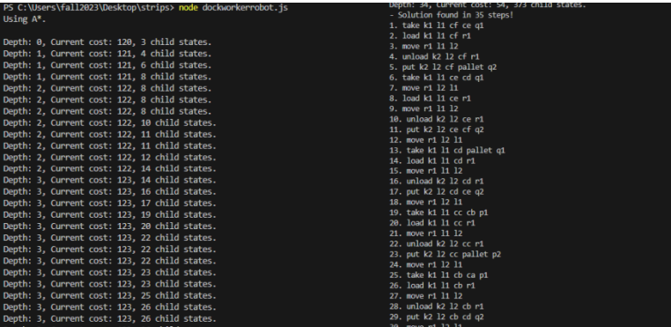

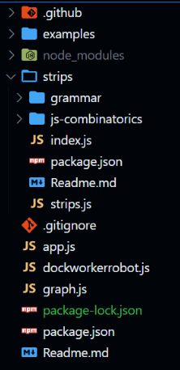

**TASK # 2:**  Provide the solution for dockworkerrobot problem using AI Planner

**DOMAIN.TXT:**

;; Specification in PDDL1 of the DWR domain

(define (domain dock-worker-robot-pos)

(:requirements :strips :typing )

(:types

location ; there are several connected locations in the

harbor

pile ; is attached to a location

; it holds a pallet and a stack of containers

robot ; holds at most 1 container, only 1 robot per location

crane ; belongs to a location to pickup containers

container)

;; there are 5 operators in this domain:

;; moves a robot between two adjacent locations

(:action move

:parameters (?r - robot ?from - location ?to - location)

:precondition (and (adjacent ?from ?to)

(at ?r ?from) (free ?to))

:effect (and (at ?r ?to) (free ?from)

(not (free ?to)) (not (at ?r ?from)) ))

;; loads an empty robot with a container held by a nearby

crane

(:action load

:parameters (?k - crane ?l - location ?c - container ?r -

robot)

:precondition (and (at ?r ?l) (belong ?k ?l)

(holding ?k ?c) (unloaded ?r))

:effect (and (loaded ?r ?c) (not (unloaded ?r))

(empty ?k) (not (holding ?k ?c))))

**PROBLEM.TXT:**

;; a simple DWR problem with 1 robot and 2 locations

;; A complete planning graph for this problem (strips.fast:

false, isSkipNegativeLiterals: true) should

display:

;; P0: 29, A1: 3, P1: 35, A2: 16

;; P1: 35, A2: 16, P2: 51, A3: 62

;; unloads a robot holding a container with a nearby crane

(:action unload

:parameters (?k - crane ?l - location ?c - container ?r -

robot)

:precondition (and (belong ?k ?l) (at ?r ?l)

(loaded ?r ?c) (empty ?k))

:effect (and (unloaded ?r) (holding ?k ?c)

(not (loaded ?r ?c))(not (empty ?k))))

;; takes a container from a pile with a crane

(:action take

:parameters (?k - crane ?l - location ?c - container ?else -

container ?p - pile)

:precondition (and (belong ?k ?l)(attached ?p ?l)

(empty ?k) (in ?c ?p)

(top ?c ?p) (on ?c ?else))

:effect (and (holding ?k ?c) (top ?else ?p)

(not (in ?c ?p)) (not (top ?c ?p))

(not (on ?c ?else)) (not (empty ?k))))

;; puts a container held by a crane on a nearby pile

(:action put

:parameters (?k - crane ?l - location ?c - container ?else -

container ?p - pile)

:precondition (and (belong ?k ?l) (attached ?p ?l)

(holding ?k ?c) (top ?else ?p))

:effect (and (in ?c ?p) (top ?c ?p) (on ?c ?else)

(not (top ?else ?p)) (not (holding ?k ?c))

(empty ?k))))

;; P2: 51, A3: 62, P3: 77, A4: 144

;; P3: 77, A4: 144, P4: 109, A5: 244

;; P4: 109, A5: 244, P5: 123, A6: 334

;; P5: 123, A6: 334, P6: 127, A7: 362

;; P6: 127, A7: 362, P7: 127, A8: 362

(define (problem dwrpb1)

(:domain dock-worker-robot-pos)

(:objects

r1 - robot

l1 l2 - location

k1 k2 - crane

p1 q1 p2 q2 - pile

ca cb cc cd ce cf pallet - container)

(:init

(adjacent l1 l2)

(adjacent l2 l1)

(attached p1 l1)

(attached q1 l1)

(attached p2 l2)

(attached q2 l2)

(belong k1 l1)

(belong k2 l2)

(in ca p1)

(in cb p1)

(in cc p1)

(in cd q1)

(in ce q1)

(in cf q1)

(on ca pallet)

(on cb ca)

(on cc cb)

(on cd pallet)

(on ce cd)

(on cf ce)

(top cc p1)

(top cf q1)

(top pallet p2)

(top pallet q2)

(at r1 l1)

(unloaded r1)

(free l2)

(empty k1)

(empty k2))

;; the task is to move all

containers to locations l2

;; ca and cc in pile p2, the

rest in q2

(:goal

(and (in ca p2)

(in cb q2)

(in cc p2)

(in cd q2)

(in ce q2)

(in cf q2))))

